EXPERIMENT 6
Demonstration of Apriori algorithm on transaction dataset to find association rules.

AIM
To demonstrate the Apriori algorithm on a grocery transactions dataset to discover frequent itemsets and association rules.

PROCEDURE
- Import pandas, requests, StringIO, and mlxtend libraries.
- Fetch the groceries CSV from a GitHub URL using requests.get().
- Split content into individual transaction strings.
- Parse each transaction into a list of items.
- Create a DataFrame with 'Transaction_Items' column.
- Convert transactions to list of lists.
- Initialize and fit a TransactionEncoder.
- Transform transactions to a boolean DataFrame.
- Apply the Apriori algorithm with min_support=0.01.
- Display frequent itemsets using frequent_itemsets.head().

CODE

import pandas as pd
import requests
from io import StringIO
url = 'https://raw.githubusercontent.com/stedy/Machine-Learning-with-R-datasets/master/groceries.csv'
response = requests.get(url)
content = response.text
transaction_strings = content.strip().split('\n')
transactions = []
for transaction_string in transaction_strings:
transactions.append([item.strip() for item in transaction_string.split(',')])
data = pd.DataFrame({'Transaction_Items': transactions})
data.head()
transactions = data['Transaction_Items'].tolist()
from mlxtend.preprocessing import TransactionEncoder
te = TransactionEncoder()
te_array = te.fit(transactions).transform(transactions)
df = pd.DataFrame(te_array, columns=te.columns_)
df.head()
from mlxtend.frequent_patterns import apriori
frequent_itemsets = apriori(
df,
min_support=0.01,
use_colnames=True
)
frequent_itemsets.head()

OUTPUT
Transactions (first 5):
[citrus fruit, semi-finished bread, margarine, ready soups] [tropical fruit, yogurt, coffee]
[whole milk]
[pip fruit, yogurt, cream cheese, meat spreads]
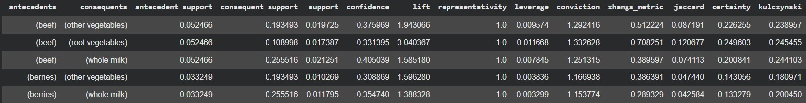
[other vegetables, whole milk, condensed milk, long life bakery product] Frequent Itemsets (top results with min_support=0.01) generated successfully.

RESULT
The Apriori algorithm successfully mined frequent itemsets from 9835 grocery transactions with minimum support of 0.01. Items such as 'whole milk' and 'other vegetables' were identified as the most frequent, forming the foundation for association rule generation.

